Ayesha Zubair
52916
Compiler Construction
Lab symbol table

Task 1:
Code:
#include<iostream>
using namespace std;

struct symbol{
string name;
string value;
string type;
int size;
};

int main()
{
int n;
symbol table[10];
cout<<"No of variables: ";
cin>>n;

for(int i=0;i<n;i++)
{
cout<<"Name: ";
cin>>table[i].name;
cout<<"Datatype: ";
cin>>table[i].type;
cout<<"Value: ";
cin>>table[i].value;

if(table[i].type=="int")
table[i].size=4;

else if(table[i].type=="float")
table[i].size=4;

else if(table[i].type=="char")
table[i].size=1;
}

cout<<"\n---Symbol Table---\n"<<endl;
cout<<"Name\tType\tValue\tSize"<<endl;

for(int i=0;i<n;i++)
{
cout<<table[i].name<<"\t";
cout<<table[i].type<<"\t";
cout<<table[i].value<<"\t";
cout<<table[i].size<<"\t";

cout<<endl;
}

return 0;
}

Output:
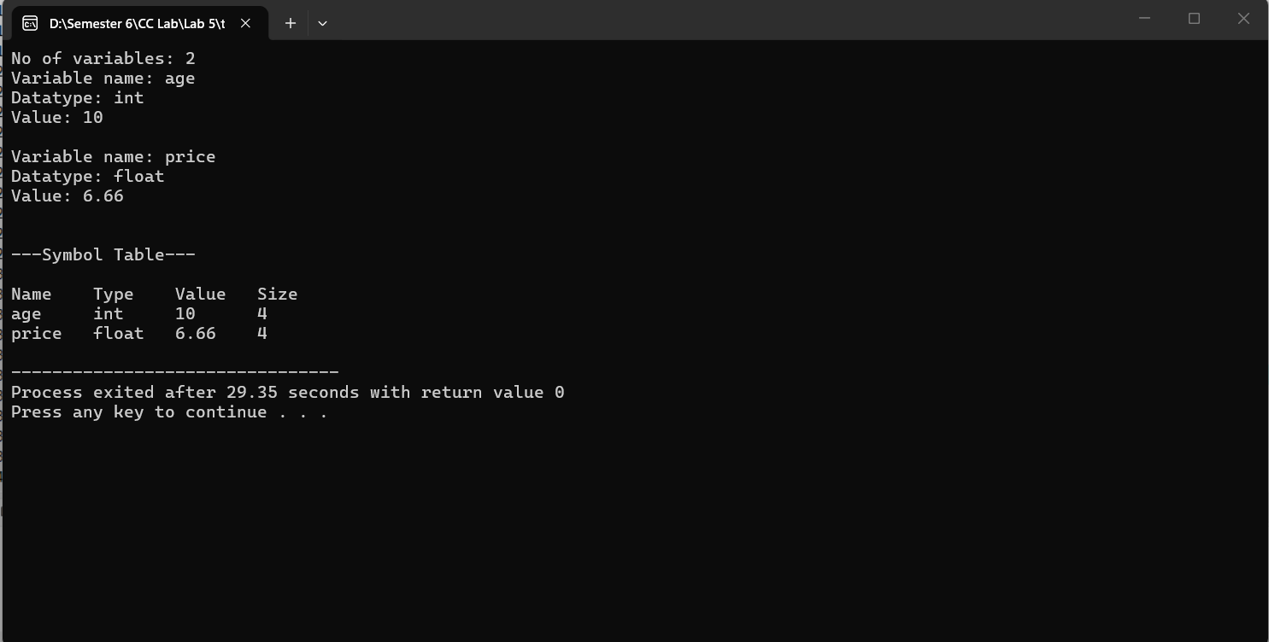

Task 2:
Code:
#include<iostream>
using namespace std;

struct symbol{
string name;
string type;
string value;
};

int main()
{
int n;
cout<<"Enter number of variables: ";
cin>>n;
string search;
symbol table[10];

for(int i=0;i<n;i++)
{
cout<<"Variable Name: ";
cin>>table[i].name;
cout<<"Datatype: ";
cin>>table[i].type;
cout<<"Value: ";
cin>>table[i].value;
cout<<endl;
}

cout<<"\n---Symbol Table---\n"<<endl;
cout<<"Name\tType\tValue"<<endl;

for(int i=0;i<n;i++)
{
cout<<table[i].name<<"\t";
cout<<table[i].type<<"\t";
cout<<table[i].value<<"\t";
cout<<endl;
}
cout<<endl;

cout<<"Enter name to search: ";
cin>>search;
cout<<endl;

for(int i=0;i<n;i++)
{
if(table[i].name==search)
{
cout<<"Name found!"<<endl;
break;
}
else
{
cout<<"Not found."<<endl;
}
}

return 0;
}

Output:
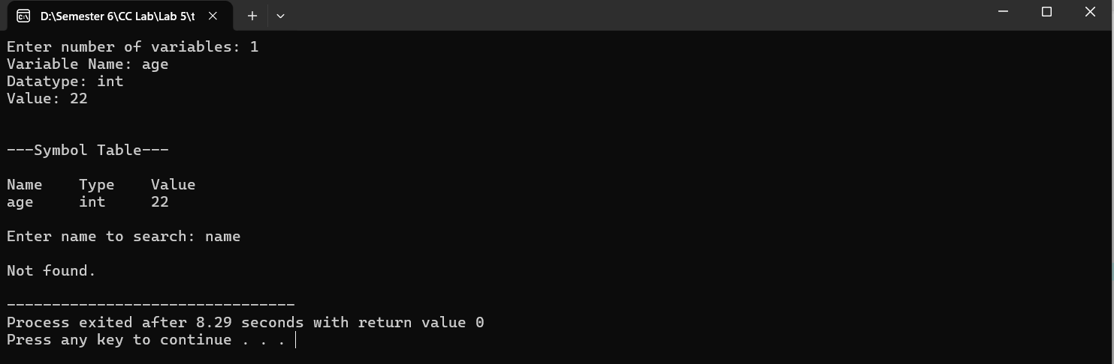
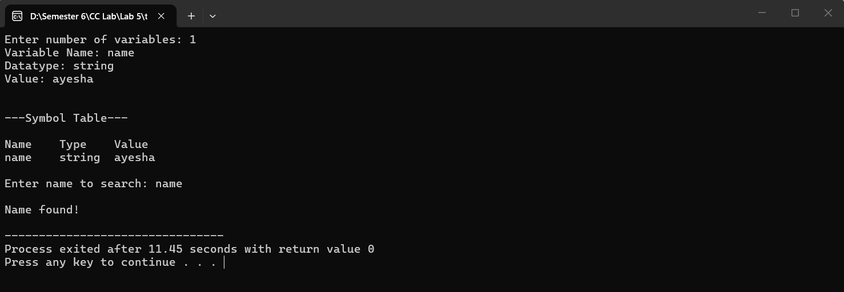

Task 3:
Code:
#include<iostream>
using namespace std;

struct symbol{
string name;
string type;
string value;
};

int main()
{
int n;
int count=0;
symbol table[10];

cout<<"Enter no of variables: ";
cin>>n;

for(int i=0;i<n;i++)
{
bool duplicate=false;
string name, type, value;

cout<<"Variable name: ";
cin>>name;
cout<<"Datatype: ";
cin>>type;
cout<<"Value: ";
cin>>value;

for(int j=0;j<count;j++)
{
if(table[j].name==name)
{
duplicate=true;
cout<<"Duplicate name"<<endl;
break;
}
}

if(!duplicate)
{
table[count].name=name;
table[count].type=type;
table[count].value=value;
count++;
}
cout<<endl;

cout<<"\n---Symbol Table---\n"<<endl;
cout<<"Name\tType\tValue"<<endl;

for(int i=0;i<n;i++)
{
cout<<table[i].name<<"\t";
cout<<table[i].type<<"\t";
cout<<table[i].value<<"\t";

cout<<endl;
}

}

/*cout<<"\n---Symbol Table---\n"<<endl;
cout<<"Name\tType\tValue"<<endl;

for(int i=0;i<n;i++)
{
cout<<table[i].name<<"\t";
cout<<table[i].type<<"\t";
cout<<table[i].value<<"\t";

cout<<endl;
} */

}
Output:
